
Hong Leong Bank Berhad
A Member of the Hong Leong Group Malaysia (97141–X)

Functional Specification Document
CrediOS for General Function

Version: V1.2
Author: LI BIN
Date Created: 2025-12-02
Last Updated: 2026-01-16

Document Control
Revision History
Version | Date | Author | Summary of Changes | Status
V 1.0 | 2025-12-14 | LI BIN | Initial Draft | Pending Review
V 1.1 | 2025-12-18 | LI BIN | Initial Draft | Pending Review
V 2.0 | 2026-01-05 | LI BIN | Update | Pending Review
V 2.1 | 2026-01-08 | LI BIN | Update | Pending Review
V 2.2 | 2026-01-12 | LI BIN | Update by comments | Pending Review
V 2.3 | 2026-01-15 | LI BIN | Update by comments | Pending Review

Condition Review / Approval of the FSD :
(1) Current LOAD$ Functionality & Processes
- All essential functions, requirements, processes, and interfaces currently active in the LOAD$ that remain necessary for CrediOS are supposed to be fully documented within the FSD for delivery.
- Should any of these elements be omitted, insufficiently detailed, or not be identified during the current FSD review version, they must remain within the delivery scope.
- If such gaps are detected following the FSD sign-off, or during the development, testing, or post-production deployment stages, the identified functions must be documented in an FSD Addendum for formal record-keeping; and the delivery schedule must be planned accordingly.
(2) Enhancement of Current LOAD$ Functionality & Processes
- For streamlined enhancement to existing LOAD$ functions, processes, handlings, and interfaces, any mismatches & gaps or insufficient details not be identified and documented during the current FSD review version, they must be filled up or/and rectified within the delivery scope.
- If such gaps are detected following the FSD sign-off, or during the development, testing, or post-production deployment stages, the identified gaps must be documented in an FSD Addendum for formal record-keeping; and the delivery schedule must be planned accordingly.
(3) New Functionality & Processes in CrediOS
- For new functions & processes & interfaces defined in the project scope-of-work, it supposed to be fully documented within the FSD for delivery.

Document Review & Approval
Team | Role | Name | Position | Signature | Date
HLB | Approver
HLB | Approver
HLB | Approver
HLB | Approver
HLB | Approver
WeTech | Product
WeTech | Business
WeTech | Engineering
WeTech | QA
WeTech | UX/UI

Reference or Related Documents
No. | Documents Name
1 | [Final] CrediOS URS AL v1.1 2025.11.21 (Compiled)_Overall

Table of content
Document Control 1
1. Background of the Project 5
1.1 Project Background 5
1.2 Key Business Objectives 5
1.3 Scope of this document 5
2. CrediOS General Function Description 6
2.1 Case Remark & Collaboration 6
2.1.1 Feature Definition 6
2.1.2 Regular Submission & Input (Submission & Input) 7
2.1.3 Automatically generated template in the Price Approval scenario 8
2.1.4 AI Intelligent Summary 8
2.1.5 View & History 9
2.2 Order Whole-Link Logs (Audit Trail & System Logs) 9
2.2.1 Overview (Overview) 9
2.2.2 Log Schema Specification (Log Schema) 10
2.2.3 Detailed Log Categories 10
2.2.4 Data Display & Access Control (Display & Access Control) 11
2.3 Role BackUP Function 11
2.3.1 Set Agent (Configuration) 12
2.3.2 Routing Logic 12
2.3.3 Agent Automatic Termination 12
2.4 Role tag Out of Office 12
2.4.1 Status Mark (Status Configuration) 13
2.4.2 Routing Logic 13
2.4.3 Constraints (Constraints) 13
2.5 Scheduler 14
2.6 Single sign-on based on Bank domain 15
3 User & Role Management 15
3.1 User Profile & Provisioning Configuration Process: 16
3.2 Role System and Responsibilities (Role Definitions) 17
3.3 Upline Logic (Upline Logic) 17
3.4 Default Permission Matrix 18
3.5 Case Query Scope Setting 20
4. Vehicle Database 20
4.1 FIS Database Logic 20
4.2 Vehicle Family Database (Family) 21
4.3 Variant Database (Variant Detail) 22
4.4 Import Plan for Assessed Value of Existing Used Car Models 24
4.5 BNM CCRIS Vehicle Make Category Matrix for the BNM 25
4.6 BNM Loan Purpose 25
4.7 Mapping between Loan Purpose and Vehicle Type 27
4.8 BNM Green/Non-Green Classification 28
5. SMS & Email Requirements 29
5.1 Overview 29
5.2 Trigger Scenarios & Content 29
5.3 Attachment & Security (PDF Protection) 30
5.4 Monitoring & Error Handling 30
5.5 System Configuration & Parameters 30
6. Migration Plan for Existing Data 30
7. EIWS Document Synchronization Requirement Specification 31
7.1. System Overview 31
7.1.1 System Positioning 31
7.1.2 Storage Architecture 31
7.1.3 Business Value 31
7.2. Synchronization Trigger Mechanism 31
7.2.1 Trigger Conditions 31
7.2.2 Synchronization Scope 33
7.3. Synchronization Content Definition 33
7.3.1 Document Classification 33
7.3.2 Synchronization Policy Configuration 33
7.4. Data Integrity Assurance 34
7.4.1 Three-Stage Verification Process 34
7.4.2 Status Tracking Mechanism 34
7.5. Exception Handling Strategy 35
7.5.1 Failure Classification 35
7.5.2 Retry Mechanism 35
7.6. Local Storage Cleanup 35
7.6.1 Local File Cleanup Prerequisites 35
7.6.2 Local File Cleanup Execution Standards 35
7.6.2.1 Local File Metadata Cleanup Definition 35
7.6.3 Audit Records 36
8.Refer Link for this document 38

1. Background of the Project

1.1 Project Background
This project aims to update the existing Hire Purchase business system of Hong Leong Bank. The project will introduce a brand new CrediOS system to replace the existing LOAD$ system, in order to address pain points such as low automation and cumbersome operations in the original system.
The sales front end, by reconstructing the customer information entry module, is committed to improving the efficiency of case submission and operational experience of frontline sales staff, thereby shortening the business turnaround time.

1.2 Key Business Objectives
- Process Automation and STP (Straight-Through Processing): Transition from "full manual approval" to "automated approval first". For high-quality application cases that meet risk policies, the system will implement end-to-end automated approval (STP), significantly reducing the cost of manual intervention.
- Customer Segmentation Process (ETB Fast-Track): For existing customers within the bank (ETB, Existing-to-Bank), the system will implement rapid application intake by leveraging a customized fast-track approval channel and reusing existing in-house data.
- AI OCR Improves Input Efficiency: Integrated OCR technology of the Gemini MultiModal Machine Learning large model enables intelligent recognition and structured extraction of loan application materials (such as ID cards, payslips, etc.), minimizing manual data entry workload.

1.3 Scope of this document
This document defines the CrediOS HP General (common) capabilities that are reused across the end-to-end case lifecycle from Application intake to Approval, Documentation/Signing, and Funding, serving as the baseline foundation for workflow execution, collaboration, auditability, data governance, and operational continuity. The scope includes:
- Case collaboration & traceability
  - Standardized Case Remark/Memo mechanism across key processing actions (e.g., Submit/Approve/Reject/Transfer/Reply KIV), with public visibility, immutable audit trail, and structured remark assistance (auto sub-headings and template/AI-assisted memo generation for submissions to Risk/CED).
- Whole-link audit trail & system logs
  - A unified Activity/Audit Log framework capturing critical lifecycle events, including status transitions, amendments (appeal/CILT), file events, system integrations, customer communications (SMS/Email), identity verification, e-signing milestones, and approval records (price/credit), with defined schema, display rules, and role-based access plus masking of sensitive content.
- Workforce routing & continuity controls
  - General operational controls to ensure uninterrupted processing, including Role Backup/Delegation (proxy handling with ownership retention) and Out-of-Office tagging with auto-redistribution rules and constraints.
- Operating model: channel, roles, and permissions
  - The baseline organizational and access control design for CrediOS, covering channel structure, user provisioning attributes, RBAC role definitions, upline/escalation logic, default permission matrix, and case query scope rules that govern who can view and process which cases.
- Reference rate scheduling service
  - A shared scheduler service to periodically retrieve standard interest rates from HOST (e.g., SBR/IBR/BLR/KLIBOR), provide reference visibility, and define high-level handling principles for approved/disbursed cases when base rates change.
- Vehicle master data & regulatory mapping foundation
  - The vehicle database hierarchy and mapping logic (FIS-to-internal Make/Family/Variant), plus key regulatory/reporting mappings required for HP processing (e.g., BNM CCRIS category, loan purpose mapping, vehicle type mapping, green/non-green classification), including import approach for used-car assessed values.
- Operational reuse & migration baseline
  - Principles for reusing existing LOAD$ SMS/Email notifications, and a high-level migration plan covering system parameters (enumerations), product configuration strategy, vehicle model database creation, and dealer data migration/onboarding approach.

2. CrediOS General Function Description

2.1 Case Remark & Collaboration

2.1.1 Feature Definition
Remark is an unstructured information communication tool that runs through the entire lifecycle of loan applications. It allows users of all participating roles to enter supplementary explanations, approval comments, or risk mitigation measures when processing orders (especially at nodes such as Submit/Transfer/Reply KIV).
- Data Nature: Only recordsmanually enteredtext information. Status changes and interface logs automatically generated by the system are not displayed in this module (see the "Order Log" module for details).
- Visibility: Public. All roles with access to the order can view historical Memos.
- Immutability : Once submitted, Memo is stored as a permanent audit trail, and modification or deletion is not allowed.

2.1.2 Regular Submission & Input (Submission & Input)
Memo Entry is located in the operation panel of any role (permanently on the right side of the page). When performing "submission-type" actions (Submit, Approve, Reject, Transfer, Reply KIV), the system shall pop up a Memo entry box (multi-line text field). As shown in the figure below:
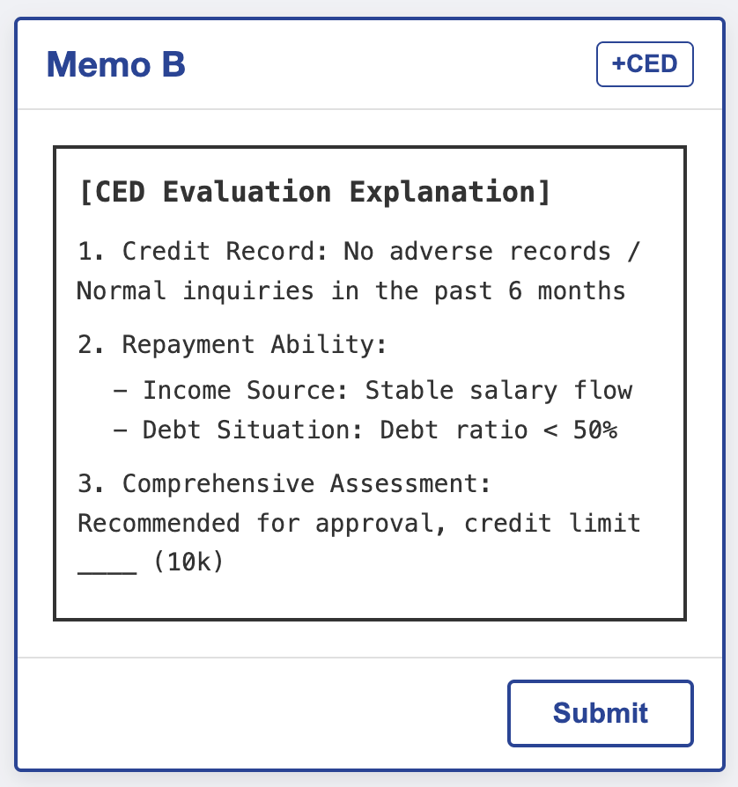
Automatic Remark Classification: Since there are different remarks in the field table, for the convenience of the Officer to selectively input, when submitting a loan, corresponding subheadings can be generated in the input box according to the checked content, and then manually entered by the Officer:
https://docs.google.com/spreadsheets/d/1AGe32tY_mXqhIkrd53JOcXX4JsvNVLOM/edit?gid=1112639955#gid=1112639955

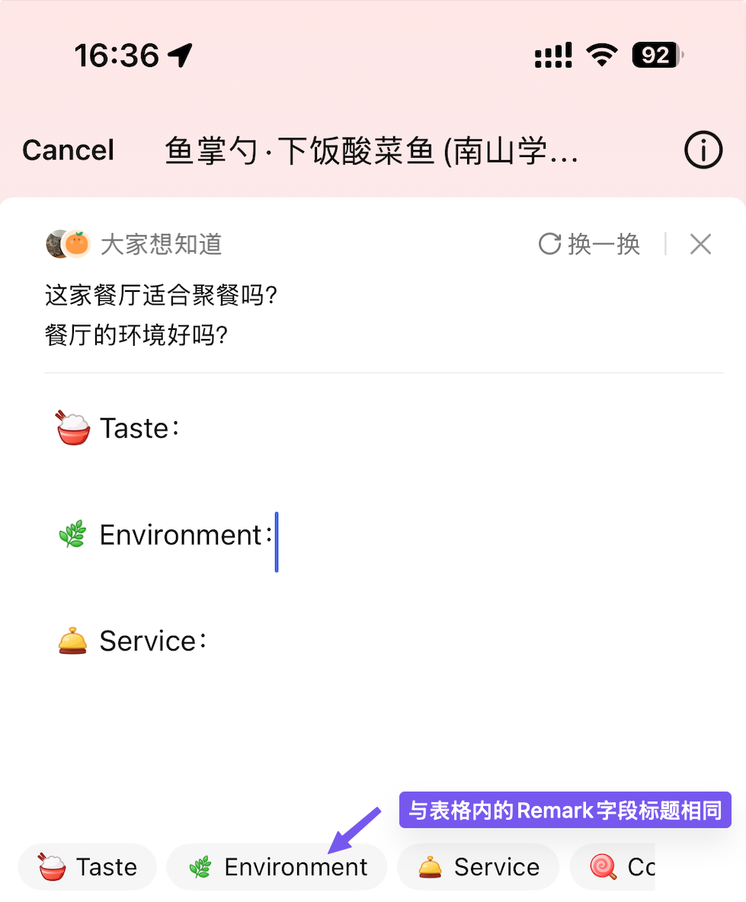
Refer to the interaction details of filling in comments in the review app

2.1.3 Automatically generated template in the Price Approval scenario
Same as Existing System,crediOS will use the same template of this scenario;

2.1.4 AI Intelligent Summary

Specialized Template Injection (Smart Template Injection) is designed for specific scenarios where Sales Officers submit to the risk side (Submit to CED/Risk). The system shall provide "Insert Template" (Insert Template) function to assist sales in writing standardized credit application reports.
Interaction Logic : Provide a dropdown menu or single-selection buttons. After selecting a template, call the large model, automatically generate a summary memo based on the customer's order information according to the template, and fill it into the input box.
Template Type:
- Individual (individual Customer)
- Non-Individual (Corporate Customer)
Non Individual | Individual
1) Deviation Request :(e.g. Exceptional approval on DSCR < 1, Deviation on income doc, Low Resales Value requesting MOF > 85% with HOS's concurrence, waiver of individual guarantee, CCRIS repayment record & etc.)  2) Nature of BusinessLength of Business/Vintage :Specific description of Nature of Business :GTR/Partner/Sole Proprietor’s experience in related field :  3) ETB Facilities Details :(e.g. BCB, Existing HP paid down of 30 months installment, Credit Card low utilization)  4) Source of fund for Down Payment :Savings / Networth Declaration :Trade In Declaration:(e.g. trade in :identify CCRIS which item / what car , YOM, free from encumbrance?)  5) Payment Conduct :CTOS (Trade Ref & Business Registered) & CCRIS adverse payment conduct : If yes, for credit related default , payment slip WITH/OR explanation required  6) Enhanced KYCUnit purchase for whom usage :Fleet purchase (no units & purpose) :Cross border financing/reason :  7) EDD Requirement :(e.g. Adverse news on company/Director/Shareholder/GTR/Partner/Owner, RCA/PEP related, High Risk Customer & etc.)  8) Mitigation & justification :(e.g. Clarification on Loss/Accumulative Loss, DSCR/DSR exceeded) | 1) Deviation Request :(e.g. DSR Test Concept, Deviation on income doc, model not listed under GRV & LRV requesting > 70% with HOS's concurrence, CCRIS repayment record, Low Fail Score with HOS's concurrence, & etc.)  2) Occupation & Nature of EmploymentBusiness / Length of Service :Specific description of nature of job :Employment < 1year, to provide previous employment details :Permanent / Probation / Contract :  3) ETB Facilities Details :(e.g. PBPV, Existing HP paid down of 30 months installment, Credit Card low utilization)  4) Source of fund for Down Payment :Savings / Networth Declaration :Trade In Declaration:(e.g. trade in : identify CCRIS which item / what car , YOM, free from encumbrance?)  5) Payment Conduct :CTOS (Trade Ref & Business Registered) & CCRIS adverse payment conduct : If yes, for credit related default , payment slip WITH/OR explanation required  6) Enhanced KYCIf No DL, state Purpose & who is user :Cross border financing/reason :Home Ownership : Owned / Employer’s / Rented / Others(If other than owned, pls update hometown address in application form & LOADS address tab)  7) EDD Requirement :(e.g. Adverse news, PEP / RCA, High Risk Customer & etc.)  8) Mitigation & justification :(e.g. DSR exceeded, Low Fail Score, Repayment record)  WITH GUARANTOR : YES / NO GUARANTOR  1) Occupation & Nature of EmploymentBusiness / Length of Service :Specific description of nature of job :Employment < 1year, to provide previous employment details :Permanent / Probation / Contract :  2) ETB Facilities Details :(e.g. BCB, Existing HP paid down of 30 months installment, Credit Card low utilization)  3) Source of fund for Down Payment :Savings / Networth Declaration :Trade In Declaration:(e.g. trade in : identify CCRIS which item / what car , YOM, free from encumbrance?)  4) Payment Conduct :CTOS (Trade Ref & Business Registered) & CCRIS adverse payment conduct : If yes, for credit related default , payment slip WITH/OR explanation required  5) Enhanced KYCIf No DL, state Purpose & who is user :Cross border financing/reason :Home Ownership : Owned / Employer’s / Rented / Others(If other than owned, pls update hometown address in application form & LOADS address tab)  6) EDD Requirement :(e.g. PEP / RCA, High Risk Customer & etc.)  7) Mitigation & justification :(e.g. DSR exceeded, Low Fail Score, Repayment record)

2.1.5 View & History
History Record List displays the complete Memo list in the sidebar of the order details page or on a separate Tab page.
- Sorting Rule: Sort in descending order by creation time (Latest on Top).
- Display Elements:
  - Header: [Role Name] - [User Name] @ [Date Time] (e.g., Credit Officer - Jason Lee @ 2023-10-12 14:30)
  - Context: Operation node at the time of submission (e.g., Action: Submit to CED)
  - Content: Complete text content.
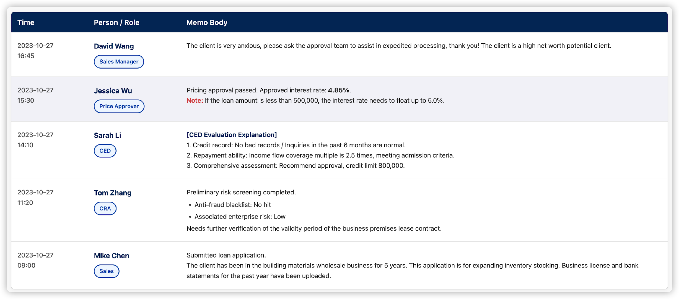

2.2 Order Whole-Link Logs (Audit Trail & System Logs)

2.2.1 Overview (Overview)
This module aims to build a whole-link order lifecycle record system. In addition to manually entered Memos, the system needs to automatically capture and persistently store all critical status changes , system interactions , customer outreach and decision approvals events. These logs will serve as the Single Source of Truth for compliance audits, troubleshooting, and operational analysis.

2.2.2 Log Schema Specification (Log Schema)
All log records must include the following standard header information (Header) and record specific business data in the details field (Payload):
- Standard Header:
  - Timestamp: DD-MM-YYYY HH:mm:ss.SSS (accurate to milliseconds)
  - Trace ID: Associated global request ID (used for cross-system link tracing)
  - Operator: Operator ID and Name (if automatically triggered by the system, marked as System)
  - Application Ref No.: Associated Loan Application Number

2.2.3 Detailed Log Categories
Logs: Amendment logs and Fields logs can be merged, but the display logic needs to be redesigned.

Log Category (Category) | Sub-Type | Trigger Scenario Description (Trigger Event) | Key Payload Fields
1. Status Transition Log  (Workflow Status) | Order Status Change | When the order status changes (e.g., Pending -> Reviewing). | • Pre-Status: Status before change  • Post-Status: Status after change  • Action: Triggered action (e.g., Submit/Reject)
2. Case  Modification Log  (Modification Log) | appeal/cilt | When an appeal or cilt occurs, it is necessary to record the change records of all fields in the order for both the previous and subsequent times; | First submission  Initiate cilt (pre- and post-modification, accurate to the field)  Initiate appeal (before and after modification, accurate to the field)  File Upload (New File Record)  File deletion (it is a concept of updating the version, not completely removing the file)  Archiving logic (full documents)
2. System Integration Log  (Integration Exec) | System Execution | When invoking an external system or internal microservice to complete a specific task. | • System Name: Target System (e.g., Host, CTOS, AML)  • Service: Interface Name  • Result: Success / Fail  • Note: Execution Remarks / Error Code
3. Customer Communication Log  (Communication) | SMS / Email Sent | When sending notifications or verification codes. | • Recipient: Customer name + Mobile number/Email  • Content: Sent body (Sensitive information needs to be masked)  • Status: Sent / Delivered / Failed
4. Identity Authentication Log  (Identity & Verification) | Email Validation | When an individual client clicks the verification link or the system performs verification. | • Email: Target Email  • Validation Result: Valid / Invalid  • Expiry: Validation Expiration Date
^ | Biometric Scan | When performing biometric verification. | • Device Name: Name of the collection device  • Customer ID: Customer ID number  • Match Score: Match score (if any)  • Status: Pass / Fail
5. Electronic Signature Log  (Digital Signing) | Consent | Status changes during the credit authorization process. | • Consent Type: e-Consent / Pre-Consent / Manual Consent  • Status: Sent / Replied / Expired / Signed
^ | E-Acceptance | Status changes during the final contract signing process. | • Document ID: Contract Document Number  • Status: Pending / Completed / Rejected
6. Approval Audit Log  (Approval Audit) | Price Approval | When the price approver completes the approval action. | • Approver: Actual Operator (Supports Support's proxy operation records)  • Role: Operational Role  • Price Before: Interest Rate/Structure Before Approval  • Price After: Interest Rate/Structure After Approval
7. Credit Approval Log  (Credit Approval Log) | Credit Approval Log | Historical credit approval records for this case | • Approver: Actual Operator (Supports Support's Proxy Operation Records)  • Amount: Installment Amount  • Tenurer: Term  • Resultr: Result (Rejected/Approved)

2.2.4 Data Display & Access Control (Display & Access Control)
- Display Location: In the "Activity Logs" panel of CrediOS Order Details.
- Sorting Rule: Default sorting is in reverse chronological order (Latest on Top).
- Privacy Protection:
  - Masking: For the SMS/email body recorded in the log, the parts involving verification codes or PII information must be masked (e.g., Your OTP is ******).
  - Access Permission: Ordinary sales staff can only view business logs except for "System Integration Logs"; Admin or IT Support roles can view complete technical logs.

2.3 Role BackUP Function
Allows Sales team (Sales Support/Officer/Sales Manager/HOS) and other TEAM roles in the system (User A) to designate another colleague of the same role (User B) as their temporary agent (Backup). During the effective period of the setting, the system automatically transfers new cases originally assigned to User A to User B's task list for processing, but the performance and data ownership of the cases still belong to User A.

2.3.1 Set Agent (Configuration)
- Entry : User individual Center / Settings / Agent Settings (My Delegate).
- Operation Item:
  - Select Agent (Select Person): Only allows selecting active users within the same administrative unit (Branch/Delivery) with the same role permissions (Role).
  - Effective Period: Select "Start Time" to "End Time" (accurate to the second).
- Verification Rule:
  - You cannot select yourself.
  - Users with the current status of "Out of Office" cannot be selected.
- Only one valid Backup setting is allowed to exist within the same time period.

2.3.2 Routing Logic
- Trigger Scenario: When the system (Auto-assignment) or a supervisor attempts to assign a new case to User A.
- Judgment Logic:
  - IF the current time is within the effective range of Backup:
  - Current Handler: Assigned to User B (Backup).
  - Case Owner: Remains as User A (Original).
  - Task List Visibility:
    - User B's To-Do List: Visible and marked as "[User A] Proxy".
    - User A's All List (All List): Visible, status synchronously updated.
- All rights reserved :
  - Despite the Backup setting, User A still retains full operational permissions (Read/Write/Submit) for this case. If User A actively intervenes in the handling, the system does not need to intercept.

2.3.3 Agent Automatic Termination
- When the system time exceeds the "End Time", the Backup relationship automatically becomes invalid.
- Subsequent newly incoming cases will resume normal routing and be directly assigned to User A.
- Note : During the agency period, the existing cases that have been assigned to User B, will not automatically revert to User A, and require User B to complete the processing or manually transfer the case.

2.4 Role tag Out of Office
Allows users to mark themselves as "on leave/unavailable". In this state, the user is removed from the automatic assignment queue, new cases will be distributed to other members of the same group according to the rules, and the case ownership will be directly transferred. Meanwhile, the user will be locked by the system and cannot accept manual assignments or act as an agent for others.

2.4.1 Status Mark (Status Configuration)
- Entry : User individual Center / Leave Management (Leave Management).
- Operation Item:
- Enable Out of Office (OOO): Switch control.
  - Leave Duration : Set the specific "Start Time" to "End Time" (accurate to seconds).
  - Conflict Validation:
    - Scenario 1 (as an agent): If the current user has been selected as a backup for someone else and the time overlaps, the system must prompt an error: "You are currently the agent of [User X]. Please contact [User X] to change the agent before setting up leave."
    - Scenario 2 (as the principal): If the current user has already set up Backup, then the OOO setting takes precedence, and the system prompts: "Enabling vacation will overwrite your Backup settings, and new cases will be transferred to other team members instead of a specific agent." (Overwritten after confirmation).

2.4.2 Routing Logic
- Trigger Scenario: When the intake system performs automatic allocation (Auto-allocation).
- Judgment Logic:
  - The system detected that Target User A is in OOO status.
  - Perform Re-distribution:
    - The system retrieves the administrative unit (Administrative Unit) to which User A belongs.
    - Filter out all members under this unit that are in the same role (Same Role) and not in the OOO status.
    - According to the rules of polling (Round Robin) or current load (Current Load), the case is assigned to User C.
- Data Change:
  - Current Handler = User C
  - Case Owner = User C
  - History Record: Case History needs to record "originally assigned to User A, automatically reassigned to User C due to OOO".

2.4.3 Constraints (Constraints)
- Cannot be used as Backup : During the OOO period, this user is invisible or grayed out (Disabled) in the selection list of "9.3 Set Agent".
- Manual assignment prohibited: When a supervisor uses the "Manual Re-Assign" function and selects an OOO user, the system should report an error and block with the message: "This user is currently on leave and cannot accept new tasks."
- Handling of existing cases:
  - OOO settings only affect newly added cases.
  - For the existing unfinished cases under this user's name , they will continue to be followed up by the original User ;

2.5 Scheduler
For CrediOS, it is necessary to regularly interface with the HOST, retrieve standard interest rates including SBR/IBR/BLR and other categories below 3, and provide a fixed page for relevant customers to consult.

Rate Name | Remark | Description
Standard Rate | The default or standard pricing level selected in the Rate Type dropdown. | Standard Rate: The standard pricing tier that is default selected in the system dropdown menu.
Base Lending Rate | A benchmark interest rate used by banks as a basis for pricing loans. | Base Lending Rate (BLR): The base rate used by banks as the basis for loan pricing (highlighted in the purple box in the figure).
Base Rate | The main reference rate used by financial institutions to determine the interest rate for loans. | Base Rate (BR): The primary reference rate used by financial institutions to determine lending rates.
CPR | Likely refers to the Cost of Funds Rate or a specific Corporate Pricing Rate. | Funding Cost Rate/Enterprise Pricing Rate: Usually refers to a bank's cost of obtaining funds or a specific enterprise pricing standard.
Fixed Deposit Rate | The interest rate paid by financial institutions on fixed-term deposit accounts. | Time Deposit Interest Rate: The interest rate paid by a Financial Institution on time deposit accounts.
Standardised Base Rate | Stands for Standardised Base Rate, the current reference rate framework in Malaysia. | Standard Base Rate (SBR) : The current latest reference rate framework for loan pricing in Malaysia.
Islamic Base Rate | A Shariah-compliant benchmark rate used as a reference for Islamic financing products. | Islamic Base Rate: A Sharia-compliant base rate used for Islamic financing products.  is the same as the value of SBR.
Islamic Financing Rate | The specific profit rate applied to Islamic financing facilities. | Islamic Financing Rate: The specific profit rate applicable to Islamic financing schemes (highlighted in the purple box in the figure).
2-Month KLIBOR | Kuala Lumpur Interbank Offered Rate with a 2-month maturity period. | 2-month Kuala Lumpur Interbank Offered Rate (KLIBOR): A reference for interbank lending rates with a 2-month tenor.
3-Month KLIBOR | Kuala Lumpur Interbank Offered Rate with a 3-month maturity period. | 3-Month Kuala Lumpur Interbank Offered Rate (KLIBOR): A reference for interbank lending and borrowing rates with a 3-month term.
6-Month KLIBOR | Kuala Lumpur Interbank Offered Rate with a 6-month maturity period. | 6-Month Kuala Lumpur Interbank Offered Rate (KLIBOR): A reference for interbank lending and borrowing rates with a 6-month term.
9-Month KLIBOR | Kuala Lumpur Interbank Offered Rate with a 9-month maturity period. | 9-Month Kuala Lumpur Interbank Offered Rate (KLIBOR): A reference for interbank lending and borrowing rates with a 9-month tenor.
12-Month KLIBOR | Kuala Lumpur Interbank Offered Rate with a 12-month maturity period. | 12-month Kuala Lumpur Interbank Offered Rate (KLIBOR): A reference for interbank lending and borrowing rates with a 12-month term.
The processing logic for customers who have already been Approved is as follows: keep the customer's Spread unchanged, recalculate interest rates such as EIR and EIR* based on the updated SBR/IBR/BLR, update the order information, and the customer does not need to re-sign the contract.
For customers who have already been Disbursed, HOST is responsible for adjusting their execution interest rate, and CrediOS will synchronously adjust their interest rate information (pending confirmation whether HOST has an interface to query their latest execution interest rate).

2.6 Single sign-on based on Bank domain
The system shall support internal cookie reuse. If a user is already authenticated in other HLB internal system scenarios, accessing CrediOS shall trigger an automatic login, provided the following conditions are met:
- Access originates from the HLB Intranet.
- The Device ID remains unchanged.
- The time elapsed since the last login does not exceed 3 days.
Note: The above rules are proposals only. Final implementation is subject to review and approval by the HLB Information Security Department.

3 User & Role Management

3.1 User Profile & Provisioning Configuration Process:
Create Staff ID (Basic Information) -> Specify Upline -> Associate Branch Coverage -> Assign Role (Role Assignment)
Attribute | Definition | Remarks
Number | Automatically assigned by the system, equivalent to staff ID
Name | Full Name
Mobile Phone Number | Mobile phone number consists of two parts: international area code and actual number
Email | Email address of the sale
Other user profiles | Other individual information of sales personnel that needs to be entered during initialization is to be supplemented
upline | superior personnel

Role | Set according to the following structure:  - Admin（role1）  - Price Approver  - Price Approver Support  - Product Admin  - Dealer Management Admin  - Dealer Management Support  - Head of Sales  - Sales Manager  - Sales Officer  Sales Support  - HP Line Admin
Direct superior  Upline | The ID of the direct supervisor, which is required for all roles except Sales Admin; its uses are as follows:  - When appealing, it is required to obtain approval from the superior by default;  - When there is no superior, it shall be submitted to the sole person in charge of the superior institution;  - Price Approver Support must specify the Price Approver role as its superior;
Additional Permission Specification | This role refers to which Region/Branch orders can be viewed by default, in addition to the orders added as Loan Proposal, and the processing permissions for these orders. | The matrix table set can refer to the default specified table of the permissions below;
Status | Activate/Deactivate

3.2 Role System and Responsibilities (Role Definitions)
The system is based on the RBAC (Role-Based Access Control) model and predefines the following core roles. Please note: "Administrative reporting relationships" and "System data permissions" are logically separated .
- Basic Roles: Sales Officer (Operator), Sales Support (Assistant).
- Management Roles: Sales Manager, Head of Sales (HOS)
- Mid-Platform Roles: Sales Admin (System Management), Price Approver (Price Approval), Product Admin (Product Configuration).
- Special Agent Logic:
- Price Approver Support: As the authorized agent of the Price Approver, the Price Approver ID they represent must be clearly specified in the system. In the actual approval process, their operations are considered equivalent to those performed by the Approver themselves.

3.3 Upline Logic (Upline Logic)
- N:1 Limit: Each user can only setonedirect upline in the system.
- Routing Rules :
- Regular Appeal: Default transfer to Upline.
- No Upline Node Processing : If a user has not configured an Upline, their Appeal request will be automatically escalated to the responsible person of the superior organization to which they belong (e.g., Region HOS).
- Configuration Reference:
The logic for setting Upline for different roles is as follows:  - Admin（role1）  - Price Approver  - Price Approver Support  - Product Admin  - Dealer Management Admin  - Dealer Management Support  - Head of Sales  - Sales Manager  - Sales Officer  - Sales Support  - HP Line Admin | - Each person can only set one Upline, but one person can be the Upline of multiple people;  - As the authorizer of the Price Approver role, Price Approver Support can perform corresponding price approvals on behalf of the Price Approver. Therefore, when Price Approver Support conducts actual operations, the approver is defaulted to the name of the corresponding Approver when filling in;

3.4 Default Permission Matrix
The default system operation permissions for each role are as shown in the following table:

Note: √√ represents the handling and review of this permission |  | HQ |  |  |  |  |  | Regions | Branch | Delivery Channel
Permissions |  | Admin（Role1） | Price Approver&Support | Product Admin | Dealer Management Admin | HP Line Admin | Dealer Management Support | Head of Sales | Sales Manager | Sales Officer | Sales Support
Case Handling | Cancel | √ |  |  |  |  |  | √ | √ | √ | √
 | Copy | √ |  |  |  |  |  | √ | √ | √ | √
 | View | √ |  |  |  |  |  | √ | √ | √ | √
 | Edit (Input) | √ |  |  |  |  |  | √ | √ | √ | √
 | Submit | √ |  |  |  |  |  | √ | √ | √
 | Appeal | √ |  |  |  |  |  | √ | √ | √
 | Confirm Reject | √ |  |  |  |  |  | √ | √ | √
 | Order Modification (CILT) | √ |  |  |  |  |  | √ | √ | √
 | Renewal (Renewal LOU) | √ |  |  |  |  |  | √ | √ | √ | √
 | Initiate Contract | √ |  |  |  |  |  | √ | √ | √ | √
 | Reply KIV | √ |  |  |  |  |  | √ | √ | √ | √
 | Appeal Approval | √ |  |  |  |  |  | √ | √
 | Price Approval |  | √ |  |  |  |  | √
 | Re-assign | √ |  |  |  |  |  | √ | √
 | Recommend Application (Recommend) |  |  |  |  |  |  | √ | √
Configuration | Product Setup | √√ |  | √√
 | Price Program Setup | √√ |  | √√
 | Role/Channel/Permission Configuration | IT |  | √√
 | HP Line Limit Maintenance  HP Line Limit Maintainance |  |  |  |  | √√
Dealer Management | Submit Dealer Empanelment |  |  |  |  |  |  | √ | √ | √ | √
 | Approve Dealer Access (Approve Dealer) |  |  |  | √1 |  | √2
 | Dealer Recommendation (Recommend) |  |  |  |  |  |  | √ | √
 | Dealer Maintain | √ |  |  | √
Other | Initiate E-hakmilik Lodgement | √ |  |  |  |  |  |  |  | √ | √
 | View Report (Report) | √ | √ | √ | √ |  |  | √ | √  Within his team
 | View AIP Result | √ | √ | √ | √ |  |  | √ | √ | √ | √
 | View Credit Review | √ | √ | √ | √ |  |  | √ | √ | √ | √
 | View Credit Check Result | √ | √ | √ | √ |  |  | √ | √ | √ | √
 | View Exposure Summary | √ | √ | √ | √ |  |  | √ | √ | √ | √

3.5 Case Query Scope Setting
Officer: By default, they can view the drafts they created, as well as the cases of Loan Proposals where they appear on the case;
SS: By default, all cases where he serves as the attending officer, as well as all cases of his Upline, can be viewed;
Manager: By default, can view cases where the Upline is his Officer, as well as cases where the documentation lists him as the Branch manager;
HOS and above: By default, all orders can be viewed;

4. Vehicle Database

The section 10 had already been moved to General Function,
Please check the latest version on this line.
CrediOS for HP_ General Function
https://docs.google.com/document/d/1BzeHTpdGXQoEOdbqek-mq0RY7I1nPibi

Based on HP's actual business scenarios, vehicle model data is configured in a hierarchical manner. First, a vehicle series database is established, and then the mapping relationship between vehicle series and detailed vehicle models is established to provide data for the selected vehicle model when an Officer submits an application.

4.1 FIS Database Logic
Since this database needs to be mapped to the vehicle model data of the external FIS, the logic of FIS will be introduced firstT20 A 42821 OTH:
Position/Field | corresponding character | Logical Meaning
1st Place | T | Brand/Manufacturer Code (Manufacturer). For example, T usually represents Toyota, P may represent Perodua, and H represents Honda.
Positions 2-3 | 20 | Engine Capacity Code (Engine Capacity). Usually refers to 2000cc. If it is 15, it represents 1500cc.
4th place | A | Transmission/Drive Type (Transmission).A stands for Automatic (Automatic Transmission); M stands for Manual (Manual Transmission).
Digits 5-9 | 42821 | Specific Model Variant Serial Number (Model Variant Serial). This is the system's internal unique identifier for a specific model (such as specific configurations like Camry, Corolla, Vios, etc.).
Positions 10-12 | OTH | Other/Special Instructions (Others/Fuel Type). Usually refers to non-standard specifications or specific fuel remarks.
The system establishes the mapping relationship between FIS and the internal vehicle model library according to the following rules:
Position/Field | corresponding character | Logical Meaning
Positions 1 to 3 | T20 | corresponds to the Make in the internal vehicle model library
Positions 1 to 7 | T20A428 | corresponds to the Family in the internal vehicle model library
Positions 1 to 12 | T20A42821OTH | corresponds to Model Detail in the vehicle model library
[COLL=V_MAKE_CODE.xls]
[COLL=V_MODEL_CODE.xls]

4.2 Vehicle Family Database (Family)
A basic vehicle model database is used to record all vehicle models and supports manual document upload or item-by-item configuration.
NAME | Sample or Selection | Remarks
MODE  Code | FC8888888 | Generate by system automatic
Make | Perodua, Proton, Tesla, BYD, Toyota, Honda, | dropdown
Family | model3,model y,camry, | Manually fill in
FIS ID | M10A112  F09A032  M08A016  F09A020  M16A289
Power type | BE,Battery Electrical Vehicle(BEV)  HE,Plug-in Hybrid Electric Vehicle(PHEV)  HG,Hydrogen Vehicle  H,Hybrid  D,Diese  P,Petrol | Select during initialization
Vehicle level | 4X4 PICK-UP, 4X4 VEHICLE, BUS, COMMERCIAL VEHICLE < 2.5 TONNE, COMMERCIAL VEHICLES > 2.5 TONNE, CRANES, FORKLIFT, MOTOR VEHICLES - PASSENGER CAR, MOTORCYCLES, MPV, OTHERS-VEHICLES/EQUIPMENTS, PICK-UP, VAN | Select and specify during initialization
National/NON-national | Y/N | Specifies whether it is a domestic vehicle
status | Active/invaild | Activate or deactivate

4.3 Variant Database (Variant Detail)
NAME | Sample or Selection | Remarks
Belong to  Family Code | FC8888888 | must be an existing vehicle series
Variant Code | VehicleID xxxxxxxxx | Automatically generated by the system
Model Detail | BYPASS TOYOTA S402  BYPASS TOYOTA NOAH  BYPASS MINI COOPER S  BYPASS MINI JOHN COOPER WORKS | Manual Configuration
FIS model code | T20A42821OTH  T20A40516OTH  B14A07716OTH  M14A00621OTH | Manually fill in
FIS Model detail | 2026 Toyota Camry 2.0HE Elite Edition (XV80 Series), Automatic Transmission, with Specific Active Safety Package
Manufacture year
Power type | BE,Battery Electrical Vehicle(BEV)  HE,Plug-in Hybrid Electric Vehicle(PHEV)  HG,Hydrogen Vehicle  H,Hybrid  D,Diese  P,Petrol | Select during initialization
Vehicle level | 4X4 PICK-UP, 4X4 VEHICLE, BUS, COMMERCIAL VEHICLE < 2.5 TONNE, COMMERCIAL VEHICLES > 2.5 TONNE, CRANES, FORKLIFT, MOTOR VEHICLES - PASSENGER CAR, MOTORCYCLES, MPV, OTHERS-VEHICLES/EQUIPMENTS, PICK-UP, VAN | Select and specify during initialization
National/NON-national | Y/N | Specifies whether it is a domestic vehicle
Resale Value (New Car only)
Green Financing
Engine Type
Engine Size
original_retail_price | 205800.00
current_market_value | "range_low": 185000.00,  "range_high": 192000.00,  "adjusted_value": 188500.00
current_market_value  last_updated | 2026-01-01
status | Active/invaild | Activate or deactivate
Each vehicle model can be manually maintained, mapped to FIS data, imported, and provide data for sales. The following is the standard vehicle model data package provided by ISM:
{
"status": "success",
"timestamp": "2026-01-08T10:15:30Z",
"data": {
"nvic": "T20A42821OTH",
"vehicle_details": {
"make_code": "T",
"make_name": "TOYOTA",
"model_name": "CAMRY",
"generation": "XV80",
"variant": "2.0HE ELITE",
"year_of_make": 2026,
"engine_capacity": 1987,
"transmission": "AUTOMATIC",
"fuel_type": "HYBRID",
"body_type": "SEDAN",
"seating_capacity": 5,
"region": "PENINSULAR MALAYSIA"
},
"pricing_info": {
"currency": "MYR",
"original_retail_price": 205800.00,
"nett_selling_price": 204500.00,
"current_market_value": {
"range_low": 185000.00,
"range_high": 192000.00,
"adjusted_value": 188500.00
},
"last_updated": "2026-01-01"
},
"technical_specs": {
"engine_type": "HE",
"drive_type": "FWD",
"safety_rating": "5-STAR NCAP"
},
"insurance_codes": {
"ism_code": "42821",
"puchong_code": "TOY-CAM-20HE-E"
}
}
}

4.4 Import Plan for Assessed Value of Existing Used Car Models
CrediOS will, on this basis, add mapping relationships for the existing used car models to facilitate the import of the model year and appraisal price of used cars:
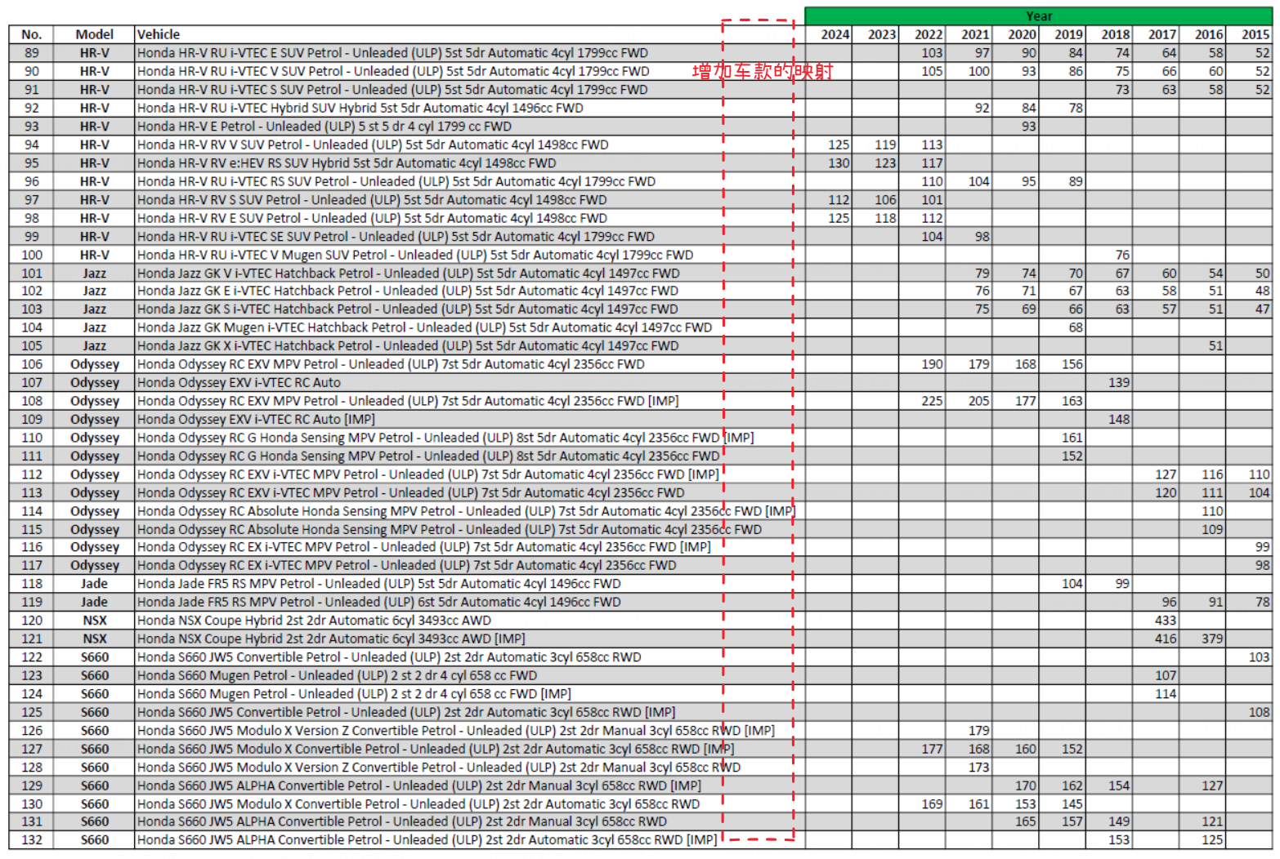

4.5 BNM CCRIS Vehicle Make Category Matrix for the BNM
Engine Abbreviation | Engine Type Description | Domestic Vehicle Code (National) | Non-National Vehicle Code (Non-National)
BE | Battery Electric Vehicle (BEV) | 11 | 21
HE | Plug-in Hybrid Electric Vehicle (PHEV) | 11 | 21
HG | Hydrogen Energy Vehicle (Hydrogen) | 12 | 22
H | Hybrid | 13 | 23
D | Diesel | 14 | 24
P | Petrol (Gasoline) | 14 | 24

4.6 BNM Loan Purpose
The selection of vehicle models has the following mapping relationships with respect to the BNM Loan Purpose field:

Vehicle Loan Purpose (Code Type: HP_LOAN_PURPOSE) | Vehicle category = New | Vehicle category NOT New | BNM Sector Code | BNM Sector Purpose
Private Registration | X |  | 0211 | Purchase Of New Vehicle
Private Registration |  | X | 0212 | Purchase Of Used Vehicle
Commercial Reg (Lorry up to 5000kg) | X | X | 0230 | Purchase Of landed Commercial Vehicle
Commercial Reg (Non Public Transport Excludes Lorry) | X | X | 0230 | Purpose Of landed Commercial Vehicle
Commercial Reg (Public Transport, Taxi, Driving School) | X | X | 0230 | Purpose Of landed Commercial Vehicle
Preferential Group Customer | X |  | 0211 | Purchase Of New Vehicle
Preferential Group Customer |  | X | 0212 | Purchase Of Used Vehicle
Commercial Reg (Lorry > 5000kg) | X | X | 0230 | Purpose Of landed Commercial Vehicle
Commercial Reg (Others) | X | X | 0200 | Purchase Of Transport Vehicle
Private Registration (Motorcycles) | X | X | 0231  new CCRIS code - 3201 | Purchase of Other Motor Vehicles for individual use only

Functional Group | CODE_ID | ROW_VERSION | START_DT | LAST_DT | CODE | DET_DESC | LABEL_CODE | ALLOW_DELETE | STATUS | SEQ | IS_DEFAULT | FIELD1
HP | 84787 |  | 18-MAR-13 14:40:36 | 31-DEC-50 00:00:00 | 9A | PURCHASE/IMPROVEMENT OF COMMERCIAL VEHICLE |  |  | A | 2 |  | 9A
HP | 84785 |  | 18-MAR-13 14:40:36 | 31-DEC-50 00:00:00 | 6K | PURCHASE OF MOTOR VEHICLE |  |  | A | 3 |  | 6K
HP | 84786 |  | 18-MAR-13 14:40:36 | 31-DEC-50 00:00:00 | 6M | PURCHASE OF CONSUMER DURABLES |  |  | A | 1 |  | 6M

4.7 Mapping between Loan Purpose and Vehicle Type
The loan purpose and vehicle type of the vehicle model are mapped by default according to the following rules. Of course, it also supports officers to make independent selections.
Owner Type | Loan Purpose | Vehicle Type Mapping | Remarks
Individual (individual) | Private Registration | Passenger Car, MPV, 4X4 Vehicle, Pick-up | is considered as low residual value or standard residual value, with MOF reaching 80%-85%
Individual (individual) | Private Registration (Motorcycles) | Motorcycles | Specifically designed for motorcycle financing
Individual (individual) | Preferential Group Customer | Passenger Car, MPV, 4X4 Vehicle | Preferred Customer Program, usually with a better Risk Band
Non-Individual (Company/SME) | Commercial Reg (Lorry up to 5000kg) | Van, Pick-up, Commercial Vehicle < 2.5 Tonne | is commonly used in light logistics, and the system usually provides an MOF ratio of >85%
Non-Individual (Company/SME) | Commercial Reg (Lorry > 5000kg to 7500kg / > 7500kg) | Commercial Vehicle > 2.5 Tonne, Cranes, Forklift | belongs to heavy commercial assets and usually involves SME GP Rating assessment
Non-Individual (Company/SME) | Commercial Reg (Non Public Transport Excludes Lorry) | Passenger Car, MPV, Van, 4X4 Vehicle | Company-owned vehicles (non-commercial), such as concierge cars or factory shuttle buses
Non-Individual (Company) | Commercial Reg (Public Transport: Taxi, Driving School) | Passenger Car, Bus | belongs to operating vehicles, and the system often classifies it as "Others" residual value, with MOF potentially limited to >70%
Non-Individual (Company) | Commercial Reg (Others) | Others-Vehicles/Equipments | Special equipment or unclassified commercial vehicles

4.8 BNM Green/Non-Green Classification
If it is a non-individual order, it is also necessary to map out the BNM Classification according to the following rules:
Code:CCRIS_NON_INDV_BNM_CLASSIFICATION
Description:CCRIS Non Indv BNM Classification
Criteria:SME GP Rating, Vehicle Green Financing
 | Non-Green | Not Applicable | Green
GP 1: Climate Change Mitigation
GP 2: Climate Change Adaptation
GP 3: No Significant Harm to the Environment | C3 |  | C1
GP 3 & GP 4: No Significant Harm to the Environment & GP 4: Remedial Efforts to Promote Transition | C3 |  | C1
GP 4: Remedial Efforts to Promote Transition | C3 |  | C2
Not Applicable | X |  | X
No GP Ratings | C5A |  | C4

5. SMS & Email Requirements

Most of the documents and materials related to this CrediOS will reuse the existing text messages and emails from the original LOAD$.

No. | File Name | Inferred Purpose / Description
1 | Parameter Details_Other_Notification.xlsx | Other Notifications - Detail Config<br>Contains the message body templates, dynamic parameters, and specific recipient rules for auxiliary notifications (e.g., e-Hakmilik status, queue tracking).
2 | Parameter_Details_Approve_Reject_Rework.xlsx | Decision Workflow - Detail Config<br>Contains the detailed message content and variable mappings for core decision events (Approval, Rejection, and Rework/Send Back).
3 | Parameter_Header_Approve_Reject_Rework.xlsx | Decision Workflow - Master Config<br>Defines the trigger points, email subjects, and communication channels for the main approval workflow.
4 | Parameter_Header_Other_Notification.xlsx | Other Notifications - Master Config<br>Defines the trigger logic and header information for non-decision related system notifications.

5.1 Overview
The system shall support automatic status updates and document delivery to designated recipients (Customer, Dealer, Sales Officer, etc.) across key lifecycle stages (Application, Approval, Disbursement) via SMS, Email, and API Integration.

5.2 Trigger Scenarios & Content
The system shall trigger notifications based on the following specific events:
- Sales Queue Exit: Send "Tracker Notification" to the Customer when the case routes out from the sales queue.
- Post-Approval: Send the Letter of Undertaking (LOU) to the designated recipients.
- Collateral Registration: Send the e-Hakmilik Lodgement Slip upon receiving a "Successful" status update.
- General Status Updates: Notify recipients during Application creation and Disbursement.

5.3 Attachment & Security (PDF Protection)
- Attachments: The system must support sending documents (e.g., LOU, e-Hakmilik Slip) as PDF attachments.
- Password Protection: All PDF attachments must be encrypted with a password based on the customer type:
  - Individual: Date of Birth OR First ID Number.
  - Non-Individual (Company): Date of Registration OR First ID Number.

5.4 Monitoring & Error Handling
- Status Inquiry: Users shall be able to query the sending status (e.g., Sent, Pending, Failed) of emails/SMS.
- Failure Alert: The system shall notify designated internal users upon delivery failure.
- Remediation: Users must have the ability to:
  - Update the recipient's email address.
  - Re-trigger the notification manually.

5.5 System Configuration & Parameters
- Recipient Configuration: Administrators can configure recipients based on rules (e.g., specific dealers vs. all dealers, specific internal roles).
- API Configuration: Support configuration of API authentication credentials, message content (body/template), sender/recipient mapping, and timing rules.

6. Migration Plan for Existing Data

The section 10 had already been moved to General Function,
Please check the latest version on this line.
CrediOS for HP_ General Function
https://docs.google.com/document/d/1BzeHTpdGXQoEOdbqek-mq0RY7I1nPibi

System Parameters: Relevant parameters that need to be reused by this system, including enumerated fields in the application form;
- Product configuration data(package/campaign/product/price):Keep the old configuration unchanged, and add a complete new configuration within the CrediOS system. The Product uses a brand-new naming and numbering system;

- Vehicle Model Database Data: Create a new vehicle model database according to the new requirements;
- Dealer Database: In the initial case, batch import, and subsequently initiate dealer access using CrediOS;
- HPline limit：Considering that during the migration, some enterprises have in-transit orders (occupying credit limits) in the old system, the total credit limit, the occupied credit limit, and the remaining credit limit will all be synchronously migrated. Since the credit line is a non-revolving credit line, there is no need to consider the situation of credit line release after the migration.

7. EIWS Document Synchronization Requirement Specification

7.1. System Overview

7.1.1 System Positioning
EIWS (Enterprise Image Workflow System) is a bank-level enterprise document management system1. It is responsible for the centralized storage, archiving, and retrieval of various files generated by the loan business system, CrediOS.

7.1.2 Storage Architecture
CrediOS utilizes a two-tier storage architecture:
- Tier 1 Storage (Temporary): Documents within the application workflow are temporarily stored on a local NAS to support rapid business access.
- Tier 2 Storage (Archiving): Once an application enters a terminated state, documents are automatically synchronized to EIWS for long-term preservation.

7.1.3 Business Value
The system ensures complete archiving of documents throughout the loan lifecycle to meet regulatory compliance requirements. Archiving targets include materials uploaded by customers, data provided by dealers, and system-generated files.

7.2. Synchronization Trigger Mechanism

7.2.1 Trigger Conditions
Synchronization tasks are only applicable to applications with the status Ended-workflow8. Different end states correspond to specific synchronization delays:
Application Status | Trigger Timing | Sync Delay (Days) | Remarks
Cancelled | Status changed to Cancelled | X | Rapidly release storage space
Disbursed Clean | After successful CRA update | X | Ensure integrity of disbursement data
Expired/Invalid | Status changed to Expired/Invalid | X | Rapidly release storage space
Final Rejected - Hardrule | Final rejection confirmation | X | Retain rejection evidence
Final Rejected - CDD | Final rejection confirmation | X | Retain rejection evidence
Final Rejected - CRIS/CTOS Timeout | Final rejection confirmation | X | Retain rejection evidence
Final Rejected - Anti-fraud AIP | Final rejection confirmation | X | Retain rejection evidence
Final Rejected - FMU | Final rejection confirmation | X | Retain rejection evidence
Final Rejected - Anti-fraud CRA | Final rejection confirmation | X | Retain rejection evidence
EDD Rejected | Rejection confirmed | X | Retain AML rejection evidence
Rejected - Confirmed AIP | Rejection confirmed | X | Retain AIP rejection evidence
Rejected - Confirmed UW | Rejection confirmed | X | Retain UW rejection evidence
Rejected - Confirmed CED | Rejection confirmed | X | Retain CED rejection evidence
Rejected - Confirmed Appeal | Rejection confirmed | X | Retain appeal rejection evidence
Execution Rules:
- Scheduling Frequency: Automatic execution once daily.
- Execution Window: Off-peak business hours (specific time is configurable).
- Trigger Method: Supports system automatic trigger only; no manual synchronization entry is provided.
Parameter Configuration:
- Configuration required for synchronization delay time.
- Configuration required for the application statuses that need to be synchronized.

7.2.2 Synchronization Scope
Each execution processes items according to the following priorities:
- Full Synchronization: Pushing all documents for applications meeting the trigger conditions for the first time.
- Incremental Synchronization: Pushing new attachments added to applications that have already been synchronized.
- Failure Retry: Retrying documents that failed in previous synchronization attempts and have not reached the retry limit.

7.3. Synchronization Content Definition

7.3.1 Document Classification
Category | Typical Files
Customer Uploaded Attachments | ID cards, proof of income, bank statements, Vehicle Ownership Certificate (VOC), collateral proof, etc.
Third-party Synchronized Data | Vehicle Sales Order (VSO), dealer invoices, identity credentials, etc.
System Generated Documents | Letter of Undertaking (LOU), rejection letters, contract texts, valuation reports, CRA reports, copies of correspondence records, etc.

7.3.2 Synchronization Policy Configuration
The system controls synchronization behavior for each document category via a configuration table:
Configuration Item | Optional Values | Description
Is_Sync_Enabled | Y / N | Whether to enable synchronization for this document category
SYNC_VERSION_MODE | LATEST_ONLY | Sync only the latest version (for non-critical docs like marketing materials)
 | ALL_VERSIONS | Sync all versions (for compliance docs like contracts)
Configuration Principles:
- Compliance Documents (Contracts, Agreement): Must be configured to ALL_VERSIONS to ensure regulatory adherence.
- Supporting Documents (reference materials, Reference materials): May be configured to LATEST_ONLY to optimize and save storage space.

7.4. Data Integrity Assurance

7.4.1 Three-Stage Verification Process
- Stage 1: Pre-push Validation
  - Check file readability and ensure file size is >0.
  - Calculate the file's SHA-256 hash.
  - Generate a list of documents pending push.
- Stage 2: Push Execution
  - Call the EIWS Web Service interface to transfer files.
  - Record the push log and mark the status as PUSHED.
- Stage 3: Storage Verification
  - Call the EIWS retrieval interface to obtain the remote file hash.
  - Compare the local hash with the remote hash for consistency.
  - Update status to VERIFIED upon successful validation.

7.4.2 Status Tracking Mechanism
Status Code | Meaning | Follow-up Action
PENDING | Awaiting synchronization | Include in the next synchronization batch
PUSHED | Pushed, pending verification | Execute storage verification
VERIFIED | Verification successful | Trigger local Cleanup
CleanupD | Local file cleared | Synchronization complete (final state)
ERROR | Synchronization failed | Retry or manual processing

7.5. Exception Handling Strategy

7.5.1 Failure Classification
Failure Type | Typical Scenarios | Handling Method
Transient Failure | Network timeout, service busy | Automatic retry
Data Error | Missing mandatory fields, invalid format | Mark as ERROR, generate error report
System Fault | EIWS service downtime | Pause batch, send alert, manual intervention

7.5.2 Retry Mechanism
- Retry Limit: A single document can be retried a maximum of X times.
- Retry Interval: Each retry occurs at a 24-hour interval.
- Escalation Rule: Documents that still fail after X consecutive synchronization cycles (X days) will trigger a system alert and be transferred for manual processing.

7.6. Local Storage Cleanup

7.6.1 Local File Cleanup Prerequisites
Local file deletion is executed only when both conditions are met:
- The document synchronization status is VERIFIED (Hash validation passed).
- The associated application status is Ended-workflow.

7.6.2 Local File Cleanup Execution Standards
- Physical Deletion:
  - Delete the original file from the local NAS.
  - Release storage space.
- Logical Retention:
  - Permanently retain document metadata (filename, sync time, EIWS reference ID, etc.).
  - Support the front-end system to retrieve metadata and jump to EIWS to view the original file.

7.6.2.1 Local File Metadata Cleanup Definition
Note: EIWS_Storage_Path is mandatory; other fields depend on the current interface status.
Field Name | Data Type | Mandatory | Description
Document_ID | VARCHAR(50) | Yes | Unique document identifier (Primary Key)
Application_ID | VARCHAR(50) | Yes | Associated application number
File_Name | VARCHAR(255) | Yes | Original filename
File_Type | VARCHAR(50) | Yes | Doc type (e.g., NRIC, LOU, VSO)
File_Size | BIGINT | Yes | File size (bytes)
File_Hash | VARCHAR(64) | Yes | SHA-256 hash value
Sync_Time | DATETIME | Yes | Completion time of sync
EIWS_Reference_ID | VARCHAR(100) | Yes | Unique reference ID in EIWS
EIWS_Storage_Path | VARCHAR(500) | No | Storage path in EIWS
Cleanup_Time | DATETIME | Yes | Local file Cleanup time
Sync_Status | VARCHAR(20) | Yes | Sync status (VERIFIED/CleanupD)
Created_By | VARCHAR(50) | Yes | Creator/System account
Created_Time | DATETIME | Yes | Record creation time

7.6.3 Audit Records
Records must be kept for the Cleanup time, target object, and EIWS unique identifier to ensure the process is traceable and auditable.
Field Name | Data Type | Mandatory | Description
Audit_ID | VARCHAR(50) | Yes | Unique audit record identifier (PK)
Document_ID | VARCHAR(50) | Yes | ID of the Cleanupd document
Application_ID | VARCHAR(50) | Yes | Associated application number
File_Name | VARCHAR(255) | Yes | Name of the Cleanupd file
EIWS_Reference_ID | VARCHAR(100) | Yes | EIWS unique identifier
Cleanup_Time | DATETIME | Yes | Execution time of the Cleanup
Operation_Type | VARCHAR(20) | Yes | Type (Fixed value: Cleanup)
Operator | VARCHAR(50) | Yes | Operator/System account
Original_File_Path | VARCHAR(500) | Yes | Original NAS path
File_Size | BIGINT | Yes | Cleanupd file size (bytes)
File_Hash | VARCHAR(64) | Yes | File SHA-256 hash
Cleanup_Status | VARCHAR(20) | Yes | Cleanup result (SUCCESS/FAILED)
Error_Message | VARCHAR(500) | No | Error info if failed
Created_Time | DATETIME | Yes | Audit record creation time

8.Refer Link for this document
Field of HP Application Form Update at 0116
https://docs.google.com/spreadsheets/d/1AGe32tY_mXqhIkrd53JOcXX4JsvNVLOM/edit?gid=1626839610#gid=1626839610

